DevOps-Code Repository with ORM Stack

Contents

1. Introduction 3
2. Workflow diagram to deploy the stack 3
3. Create stack for the DevOps-Code Repository. 4
4. Plan the Job 6
5. Apply the Job 8
6. Verify in the Console 8
7. Destroy the stack 9

Introduction
In the DevOps service, User can create their own private code repositories or connect to external code repositories such as GitHub, GitLab, Bitbucket Cloud, Visual Builder Studio, Bitbucket Server, and GitLab Server.

Workflow diagram to deploy the stack
Below diagram shows how the Terraform Artifact are applied in the OCI. While creating an ORM stack, using terraform deliverables Init, Plan and Apply is the flow to provision the resource in the OCI. We can have the deliverables in any of below.
- GitLab/GitHub Repo
- Bitbucket
- Can be in folder/.zip in the local disk
- Object Storage Bucket
- Can be in compartment
- Oracle provided Template


Create stack for the DevOps-Code Repository.

Go to OCI Console Developer Services Resource Manager Stacks select the compartment Create Stack

My Configuration Folder Browse Select the “scm_service” folder that contains the terraform Upload
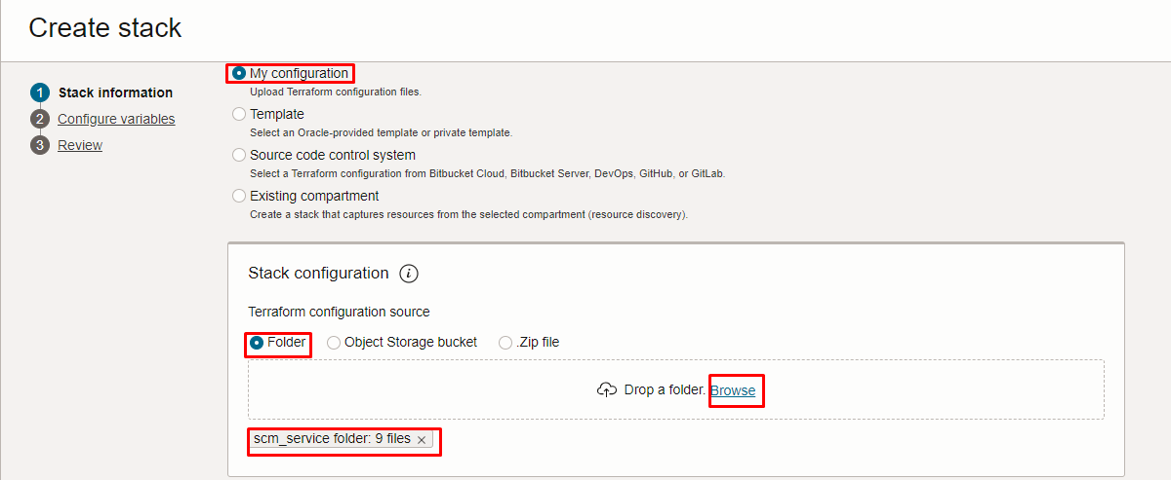
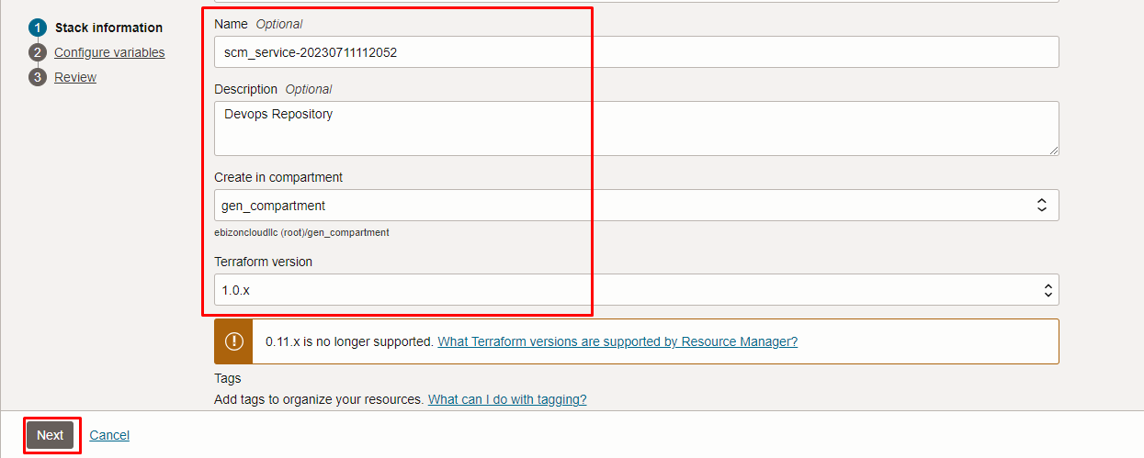
Click “NEXT”

Select the parameters as per the below screen,

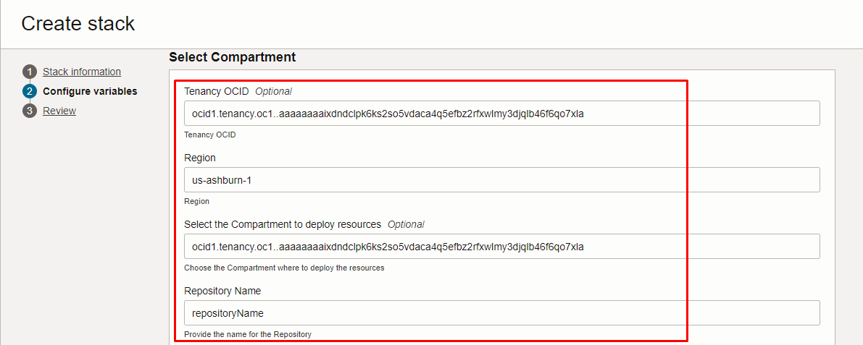
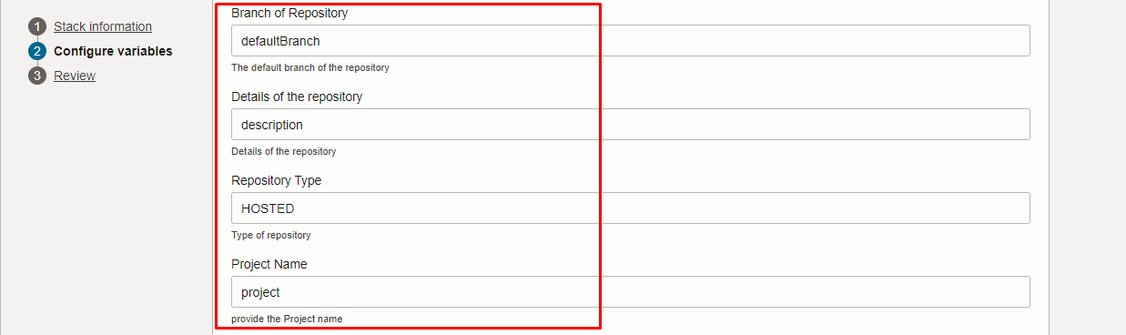
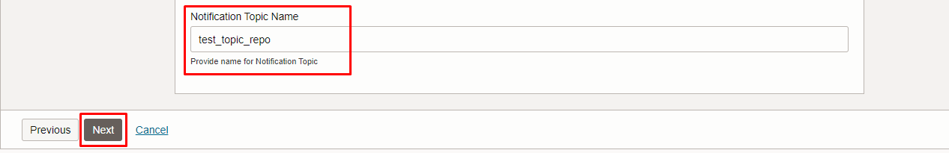
Click “NEXT” Click “CREATE”

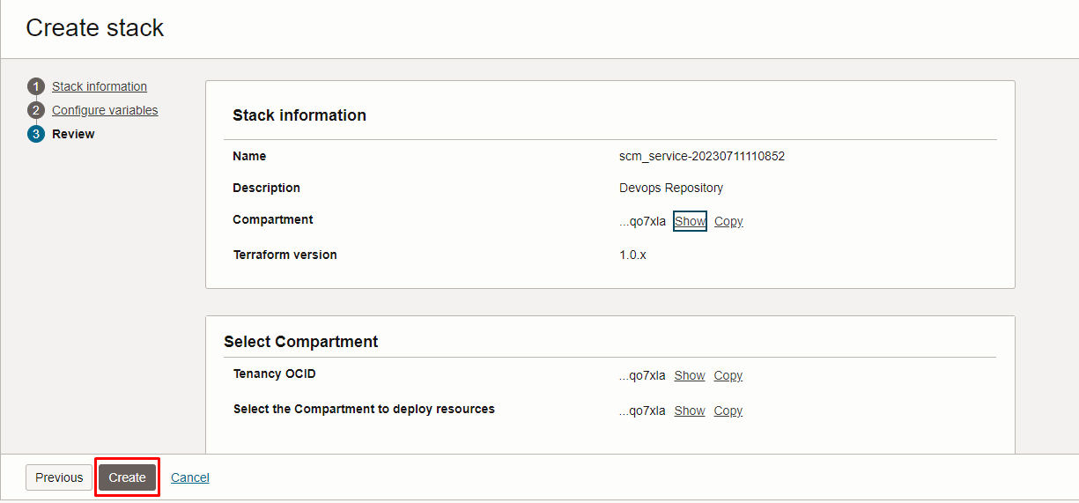

Plan the Job

Click the “Plan”

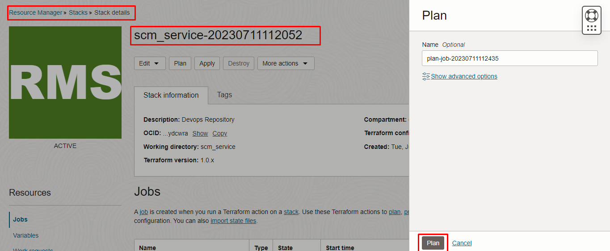
Verify the Plan is successful.

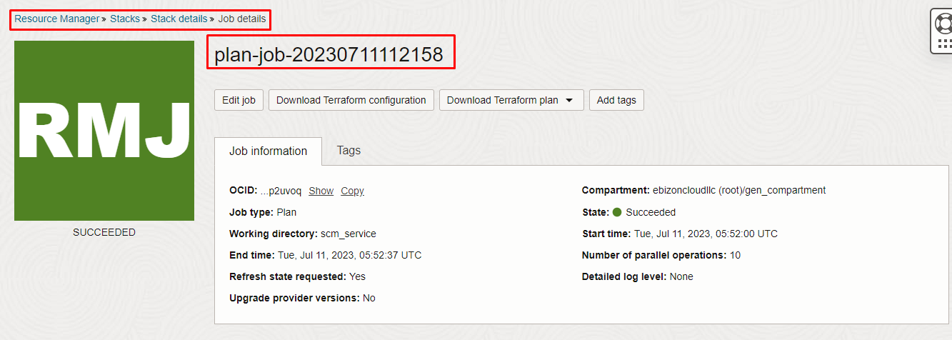

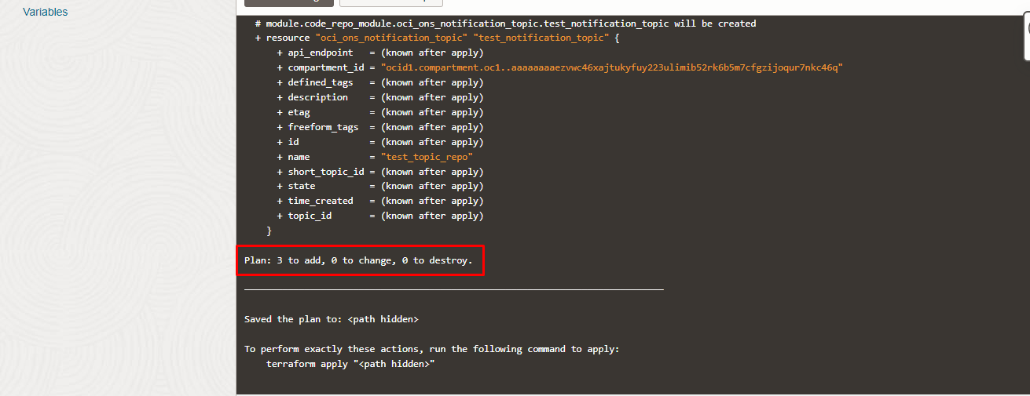

Apply the Job

Once the “plan” is success, now click “Apply”

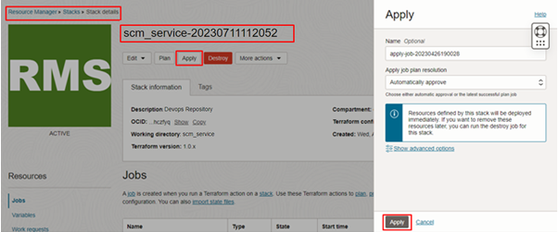

Verify the Apply is successful.

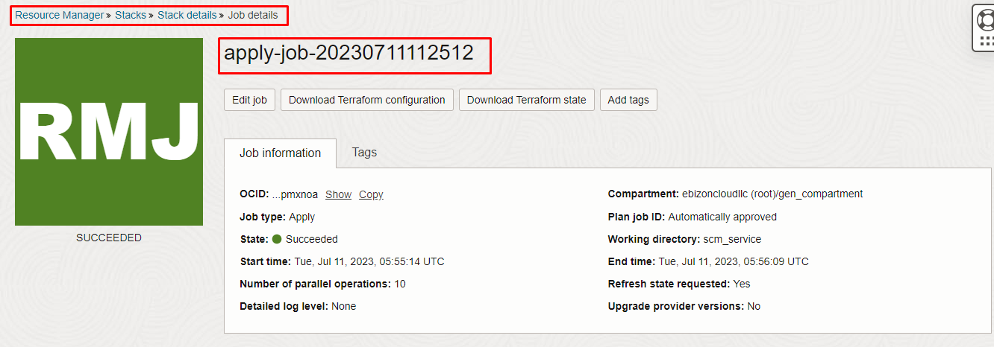
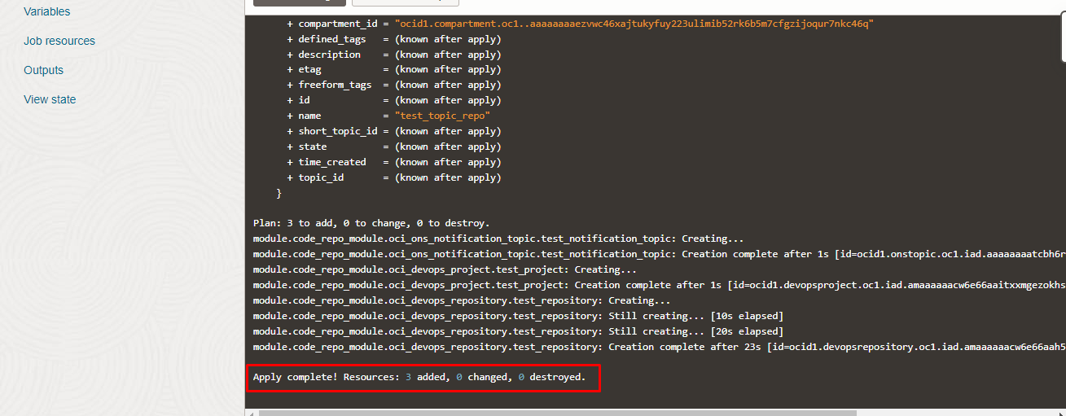

Verify in the Console

Go to OCI Console Developer Services Devops

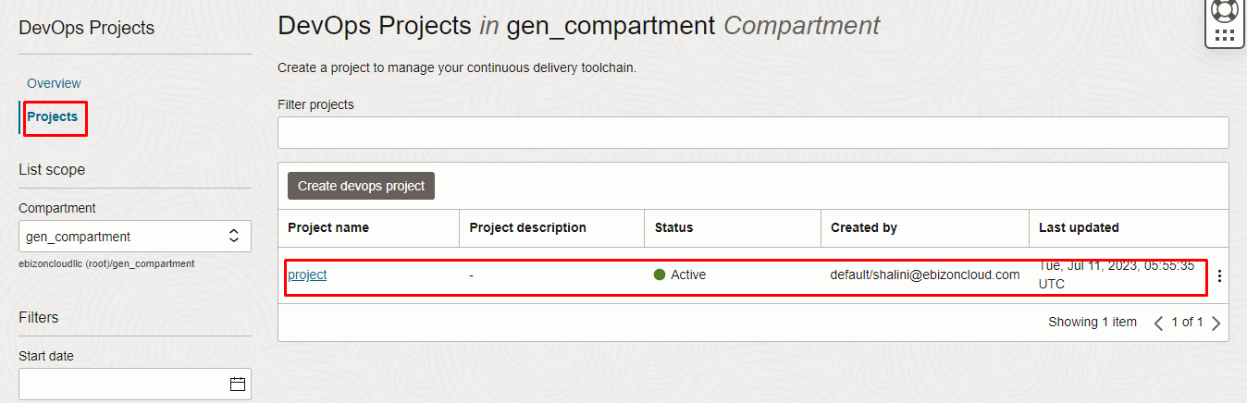
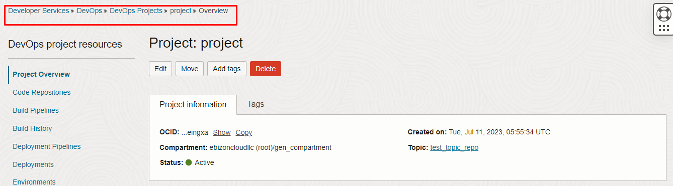
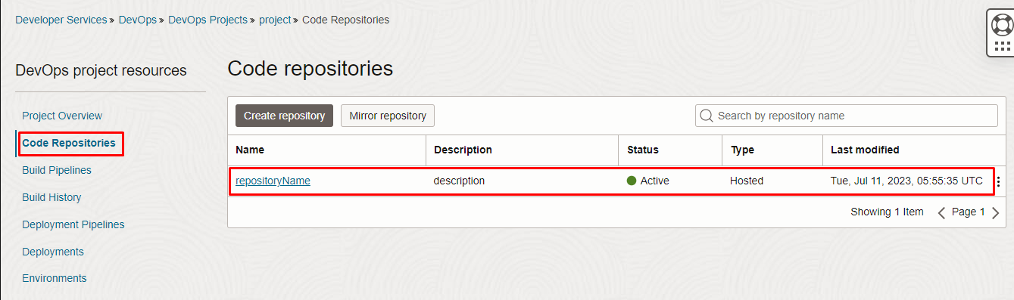
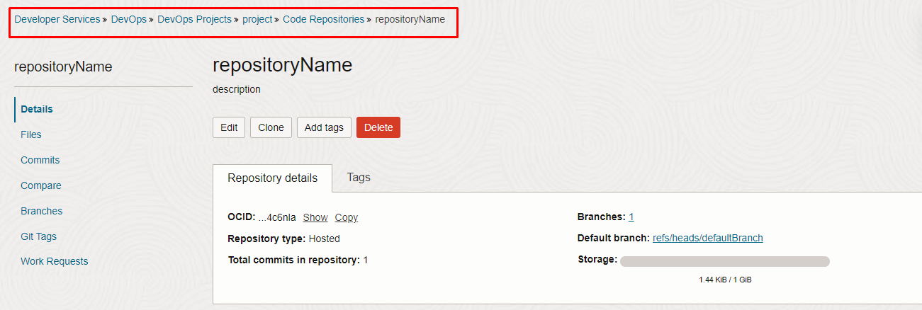

Destroy the stack

Create a destroy job in Resource Manager to release resources associated with a stack and clean up the tenancy. Once destroyed data cannot be recovered from resources.
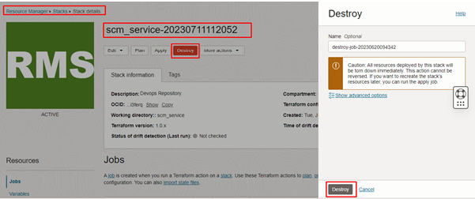

####END####

